Guideline to the Management of Herbicide Resistance
The Herbicide Resistance Action Committee (HRAC) is an industry initiative which fosters cooperation between plant protection manufacturers, government, researchers, advisors and farmers. The objective of the working group is to facilitate the effective management of herbicide resistance.

AgrEvo, American Cyanamid, BASF, Bayer, DowElanco, DuPont, F.M.C., Monsanto, Novartis, Rhône-Poulenc, Rohm and Haas, Tomen, Zeneca.

HRAC is regionally represented by the following working groups:
- European Herbicide Resistance
- Working Group (EHRWG)
- North American Herbicide Resistance Working Group (NAHRWG)
- National resistance working groups in Australia, South Africa, and others.

Table of Contents
- Background
- Definitions
- The process of selection for herbicide resistance
- Resistance risk assessment
- Guidelines for the prevention and management of herbicide resistance
- Herbicide rotation and herbicide mixtures
- HRAC site of action classification
- What to do in cases of confirmed herbicide resistance
- Conclusions and references

I. Background
In recent years, there has been an increasing reliance on modern herbicides leading to a reduction in the need for ‘traditional’ techniques of weed control. Cropping patterns have adapted, driven by the possibility to further increase crop output, to rely more and more on these products. Whilst economically this shift has been rewarding to farmers, some negative consequences have emerged which now need to be addressed in the interest of longer term sustainability.
One result of modern agriculture and the reliance on herbicides is the emergence of populations of weeds which are resistant to products designed to control them. All natural weed populations regardless of the application of any weed killer probably contain individual plants (biotypes) which are resistant to herbicides. Repeated use of a herbicide will expose the weed population to a "selection pressure" which may lead to an increase in the number of surviving resistant individuals in the population. As a consequence, the resistant weed population may increase to the point that adequate weed control cannot be achieved by the application of that herbicide.
The first case of herbicide resistance in weeds was identified in 1964. Currently, there are recorded more than 150 resistant grass and broadleaf weed biotypes in about 50 countries worldwide (Heap 1997). In spite of this seemingly dramatic development, no herbicides have been lost to agriculture; they are today, and will remain, an integral part of food production through their effective use in combination with other weed control practices.
II. Definitions
Weed Resistance – Resistance is the naturally occurring inheritable ability of some weed biotypes within a given weed population to survive a herbicide treatment that would, under normal use conditions, effectively control that weed population. Selection of resistant biotypes may result in control failures.
Cross Resistance – Cross resistance exists when a weed population is resistant to two or more herbicides. The presence of a such a mechanism can complicate the selection of alternate herbicides as tools to control a resistance situation. It is for this reason that management strategies must incorporate more than simply a switch of product.
Resistance Mechanisms – The resistance mechanism refers to the method by which a resistant plant overcomes the effect of a herbicide. The mechanism present will influence the pattern of resistance, particularly to the cross resistance profile and the dose response. The most common mechanisms of resistance are explained briefly below.
Compartmentalism Sequestration – This means that the herbicide is removed from sensitive parts of the plant cell to a tolerant site, such as a vacuole, where it is effectively harmless to plant growth.
Herbicide Site of Action – Refers to the biochemical mechanism by which a herbicide causes growth to cease in target weeds. Herbicides can be classified into groups according to their site of activity within the plant (see table 2).
III. The process of selection for herbicide resistance
It is assumed that a small number of plants in any weed population is naturally resistant to a given herbicide and that repeated application of that herbicide will allow these plants to survive and set seed. Over a period of several such ‘selections’ the resistant biotype can dominate the weed population.
This process is shown diagrammatically below:
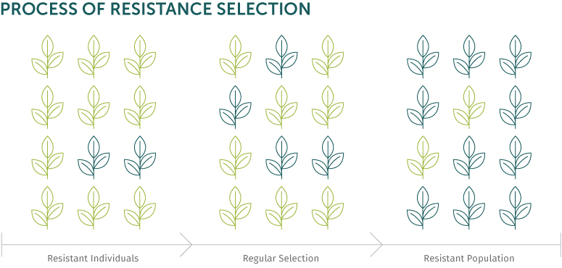
IV. Resistance risk assessment
How does a farmer establish that a herbicide resistance problem is developing or if his farming practices may lead to resistance appearing?
There are several factors to consider when evaluating herbicide resistance risk. Some of these relate to the biology of the weed species in question, others relate to particular farming practices. Some examples are given below:
Biology and genetic makeup of the weed species in question
Number or density of weeds: As resistant plants are assumed to be present in all natural weed populations, the higher the density of weeds, the higher the chance that some resistant individuals will be present.
Natural frequency of resistant plants in the population: Some weed species have a higher propensity toward resistance development; this relates to genetic diversity within the species and, in practical terms, refers to the frequency of resistant individuals within the natural population.
Seed soil dormancy potential: Plant species with a longer soil dormancy will tend to exhibit a slower resistance development under a selection pressure as the germination of new, susceptible, plants will tend to dilute the resistant population.
Crop management practices which may enhance resistance development
Frequent use of herbicides with a similar site of action: The combination of ‘frequent use’ and ‘similar site of action’ is the single most important factor in the development of herbicide resistance.
Cropping rotations with reliance primarily on herbicides for weed control: The crop rotation is important in that it will determine the frequency and type of herbicide able to be applied. It is also the major factor in the selection of non-chemical weed control options. Additionally, the cropping period for the various crops will have a strong impact on the weed flora present.
Lack of non-chemical weed control practices: Cultural or non-chemical weed control techniques, incorporated into an integrated approach is essential to the development of a sustainable crop management system.
Table 1: Assessment of the Risk of Resistance Development per Target Species
Cropping System Evaluation
 | Risk of Resistance
Management option: | Low | Moderate | High
Herbicide mix  or rotation in cropping system | > 2 modes of action | 2 modes of action | 1 mode of action
Weed control in cropping system | Cultural*, mechanical and chemical | Cultural and chemical | Chemical only
Use of same mode of action per season | Once | More than once | Many times
Cropping system | Full rotation | Limited rotation | No rotation
Resistance status to mode of action | Unknown | Limited | Common
Weed infestation | Low | Moderate | High
Control in last 3 years | Good | Declining | Poor
*Cultural control can be by using cultivation, stubble burning, competitive crops,
stale seedbeds, etc.
Table 1 (above): Provides a checklist of the major risk factors within a cropping system and ranks these as 'low', ‘medium’, or ‘high’ risk of resistance development.
The checklist is to be used per weed species where a 'Cropping System' in its simplest form is the management of crop production in an individual field.
Failure to achieve expected weed control levels does not in most cases mean that a farmer has resistance. A full analysis of the herbicide application, rate of use, weed type and stage of growth, climatic conditions and agronomic practice should be reviewed.
If, after the initial investigation, resistance is still suspected, then consideration of historical information may point to factors leading to resistance development. The following questions are recommended:
- Has the same herbicide or herbicides with the same site of action been used in the same field or in the general area for several years?
- Has the uncontrolled species been successfully controlled in the past by the herbicide in question or by the current treatment?
- Has a decline in the control been noticed in recent years?
- Are there known cases of resistant weeds in adjacent fields, farms, roadsides, etc.?
- Is the level of weed control generally good on the other susceptible species except the ones not controlled?
If the answer to any of these questions is 'yes' and all other factors have been ruled out, then resistance should be strongly suspected. Steps should then be taken to leave a small area in order to collect a sample of whole plant or seed from the suspected resistant weed population for a resistance confirmation test.
Seed Sample from Suspect Plant:
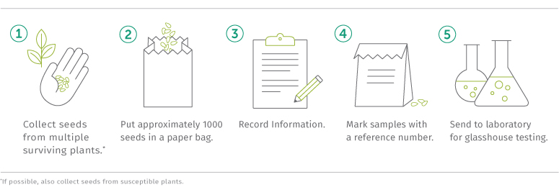

V. Guidelines for the prevention and management of herbicide resistance
The prevention of resistance occurring is an easier and cheaper option than managing a confirmed resistance situation.
Experience has shown that simply changing herbicides is not enough to overcome resistance in the mid to long term and that a sustainable, integrated system needs to be developed which is appropriate for the farm in question.
Integrated Weed Management is defined as the use of a range of control techniques, embracing physical, chemical and biological methods in an integrated fashion without excessive reliance on any one method (Powles and Matthews, 1992).
The following information outlines the three key areas of weed management: crop management, cultural techniques and chemical tools which, when employed in a rotational and integrated approach will help to reduce the selection pressure on any weed species – hence significantly reducing the chance of survival of resistant weeds.
Rotation of Crops
The principle of crop rotation as a resistance management tool is: to avoid successive crops in the same field which require herbicides with the same site of action for control of the same weed species.
Crop rotation allows the following options:
- Different crops will allow rotation of herbicides having a different site of action.
- The growth season of the weed can be avoided or disrupted.
- Crops with differing sowing times and different seedbed preparation can lead to a variety of cultural techniques being employed to manage a particular weed problem.
- Crops also differ in their inherent competitiveness against weeds. A strongly competitive crop will have a better chance to restrict weed seed production.
Cultural Techniques
Cultural (or non-chemical) weed control methods do not exert a chemical selection pressure and assist greatly in reducing the soil seed bank. Cultural techniques must be incorporated into the general agronomy of the crop and other weed control strategies. Not all of the examples given are adequate in all situations.
Some of the cultural measures for weed control could include:
- cultivation or ploughing prior to sowing to control emerged plants and to bury non-germinated seed
- delaying planting so that initial weed flushes can be controlled with a non-selective herbicide
- using certified crop seed free of weed
- post-harvest grazing, where practical
- stubble burning, where allowed, can limit weed seed fertility
- in extreme cases of confirmed resistance, fields can be cut for hay or silage to prevent weed seed set
VI. Herbicide rotation and herbicide mixtures
Herbicide rotation or mixtures refers to the rotation or mixtures of Herbicide Site of Action against any identified weed species. HRAC has recently prepared a classification of herbicides according to site of action (summary shown as table 2). When planning a weed control program, products should be chosen from different site of action groups to control the same weed either in successive applications or in mixtures.
A general guideline for the rotation of chemical groups should consider:
- avoid continued use of the same herbicide or herbicides having the same site of action in the same field, unless it is integrated with other weed control practices
- limit the number of applications of a single herbicide or herbicides having the same site of action in a single growing season
- where possible, use mixtures or sequential treatments of herbicides having a different site of action but which are active on the same target weeds
- use non-selective herbicides to control early flushes of weeds (prior to crop emergence) and/or weed escapes
From experience, we can conclude that rotation of herbicides alone is not enough to prevent the development of resistance. To retain these valuable tools, the chemical rotation explained must be employed in association with at least some of the other weed control measures outlined. In cases where metabolic resistance is already present, the site of action of the herbicide is not always the key criterion. In these cases, the mechanism of degradation can be very important and cross site of action groups and chemistries. No classification of herbicides relating to degradation is available and such examples need to be handled on a case-by-case basis.
The Use of Chemical Mixtures to Prevent Resistance
Mixtures can be a useful tool in managing or preventing the establishment of resistant weeds.
For chemical mixtures to be effective, they should:
- include active ingredients which both give high levels of control of the target weed; and,
- include active ingredients from different site of action groupings
The HRAC classification of herbicides according to site of action is in itself not a recommendation of which herbicide to use. The system is not based on resistance risk assessment but solely chemical site of action. The guide is designed to be used as a tool to select herbicides from different site of action groups so that appropriate mixtures or rotations can be planned within an integrated weed management system.
Additional to the above guideline, the grower should:
- know which weeds infest his field or non-crop area and where possible, tailor his weed control program according to weed densities and/or economic thresholds
- follow label use instructions carefully; this especially includes recommended use rates and application timing for the weeds to be controlled
- routinely monitor results of herbicide applications, being aware of any trends or changes in the weed populations present
- maintain detailed field records so that cropping and herbicide history is known
VII. HRAC site of action classification
Classification of Herbicides According to Site of Action
Visit hracglobal.com to view the Global Classification Lookup tool.
VIII. What to do in cases of confirmed herbicide resistance
In cases where a control failure has been confirmed as resistant, immediate action is required to limit further seed production of the resistant plants.
The degree of the action will depend on the stage of the crop in the field and the extent of the problem.
Some options to consider:
- Eradicate the remaining weed population if growing in patches in order to limit
build-up and spread of seed in the soil
- Limit the field to field movement of resistant populations by cleaning planting, cultivation and harvesting equipment to avoid transfer of resistant weed seed
- Avoid using the herbicide to which resistance has been confirmed unless used in conjunction with herbicides having a different site of action, active on the resistant weed population
- If the resistant population is widespread, consider grazing the crop or cut for feed being careful not to transfer resistant seed via manure
- Select these fields for rotation or set aside for the following cropping season
- Seek advice to assist in the long term planning of weed control in these fields
Once resistant weed numbers are at a controllable level, implementation of an integrated weed management system as outlined in this document will ensure that crops can continue to reach high levels of productivity in the fields in question.
A recent case study analysis carried out in England (ref. Orson and Harris, 1997) has identified that the development of resistance can be categorized into stages, with each stage requiring a new intensity of management. These management levels naturally carry a cost over what is considered as the standard farming practice. An example is the option of delayed sowing.
Whilst this is a very effective tool for managing weed numbers, the cost of doing so – if yield is reduced – can be significant.
The possible increased costs incurred to manage resistance must be measured against the impact of not applying these measures. In extreme cases, the rapid increase of uncontrollable weeds will also severely affect crop yields and may eventually impact land value itself. Key to the measurement of the cost of resistance management is the inclusion of several variables such as crop yield potential, commodity prices, local costs of various techniques such as ploughing, the weed species, the soil type and so on. This means that a cost evaluation can only be accurate on a local level and extrapolation from other situations can offer principles but not the specific detail.
IX. Conclusions and references
How quickly the resistant weed species will revert to "natural levels" within the population, if ever, will depend on a number of factors such as the relative fitness of the resistant versus susceptible biotypes, the weed's germination pattern and the weed's reproductive capabilities (genetics of resistance, pollination system, number of seeds produced per season, seed bank longevity, etc.).
It is only through the development and implementation of an integrated weed management program utilizing as wide a variety of weed control practices as are economically feasible that the problem can be effectively managed or prevented.
Steps towards the management of herbicide resistance
- Assessment of risk through a cropping system checklist
- Evaluation of options (including costs) to be adapted to local conditions
- Implementation of a sustainable weed control program
- Rotation of crops to enable a variety of weed control options
- Rotation of cultural practices to lower the reliance on herbicides
- Rotation of herbicide site of action to reduce the likelihood of resistance to a specific product group

Further Information
Internet home page: http://www.hracglobal.com/

Crop Life International
143 Avenue Louise
1050 Brussels, Belgium
croplife@croplife.org
Internet home page: http://www.croplife.org/

The development of resistance in a field is a process of selection. It means that the resistant plant can degrade a herbicide to non-phytotoxic substances faster than a normal sensitive plant, thereby surviving a herbicide treatment in much the same manner as many crop plants. “Within a plant” may mean that a herbicide no longer binds to its normal site of action due to a change in the structure of the target site, thereby allowing the plant to survive the herbicide treatment which relies on this site for its activity.

