Global HRAC Issues Management Working Group (IMWG) Charter

Primary Objectives
Within the scope defined by HRAC constitution the IMWG will:
- Identify and prioritize current issues that GHRAC can impact and should engage in
- Identify and prioritize possible future issues that GHRAC can impact
- Devise action plans, timelines, and assignments for addressing identified high priority issues
Members
- Harry Strek
- Mark Peterson
- Other Volunteers?
Team Development
Phase I – Structure, membership, objectives
Phase II – Gather inputs, brainstorm issues
Phase III – Establish action plans and timelines

Issue Management Process
Conceptually, issues will be solicited by the Issues Management Working Group (IMWG) from a variety of sources. These would include GHRAC members, CLI staff, regional HRACs, or external stakeholders such as academics, regulators, etc. On a quarterly basis, the IMWG will compile inputs, look for overlap between issues, and in some cases seek clarification of the issue from the submitter. Another source of input would be from within the IMWG as a result of brainstorming exercises to proactively identify future issues. The IMWG will then evaluate issues against a set of criteria. Possible criteria might include:
- Relevance to herbicide resistance
- Urgency
- Scope (local or global) and potential impact
- Is the issue actionable? If so, resource and time requirements to address
- Purely technical or more policy related?
- Possible actions (white paper, journal article, new research, leverage of current resources, etc.)
A review of prioritized issues and Working Group recommendations would be submitted to the GHRAC committee for approval or further input. Upon approval, the IMWG would then bring this up to the CLI Stewardship Committee for discussion to ensure that our initiative does not conflict with current or future CLI initiatives. Following this step, the IMWG would then devise plans, timelines, and resourcing (based mainly on original recommendations). The Working Group would oversee implementation and provide regular updates to the GHRAC committee. Final work products would be communicated back to relevant stakeholders and possibly posted on the HRAC website to be leveraged further.
In some cases there may be overlapping interests with known or unknown initiatives from other organizations (e.g., WSSA, ASA EWSS, etc.). If this is evident, the potential for a cooperative approach and leveraging resources may be explored, if it is judged that it would help to increase the capability to reach the desired goals of the particular issue management plan and would not limit our own space in dealing with something we have decided is important to us. This will be done within the IMWG and then communicated to the membership for a decision.

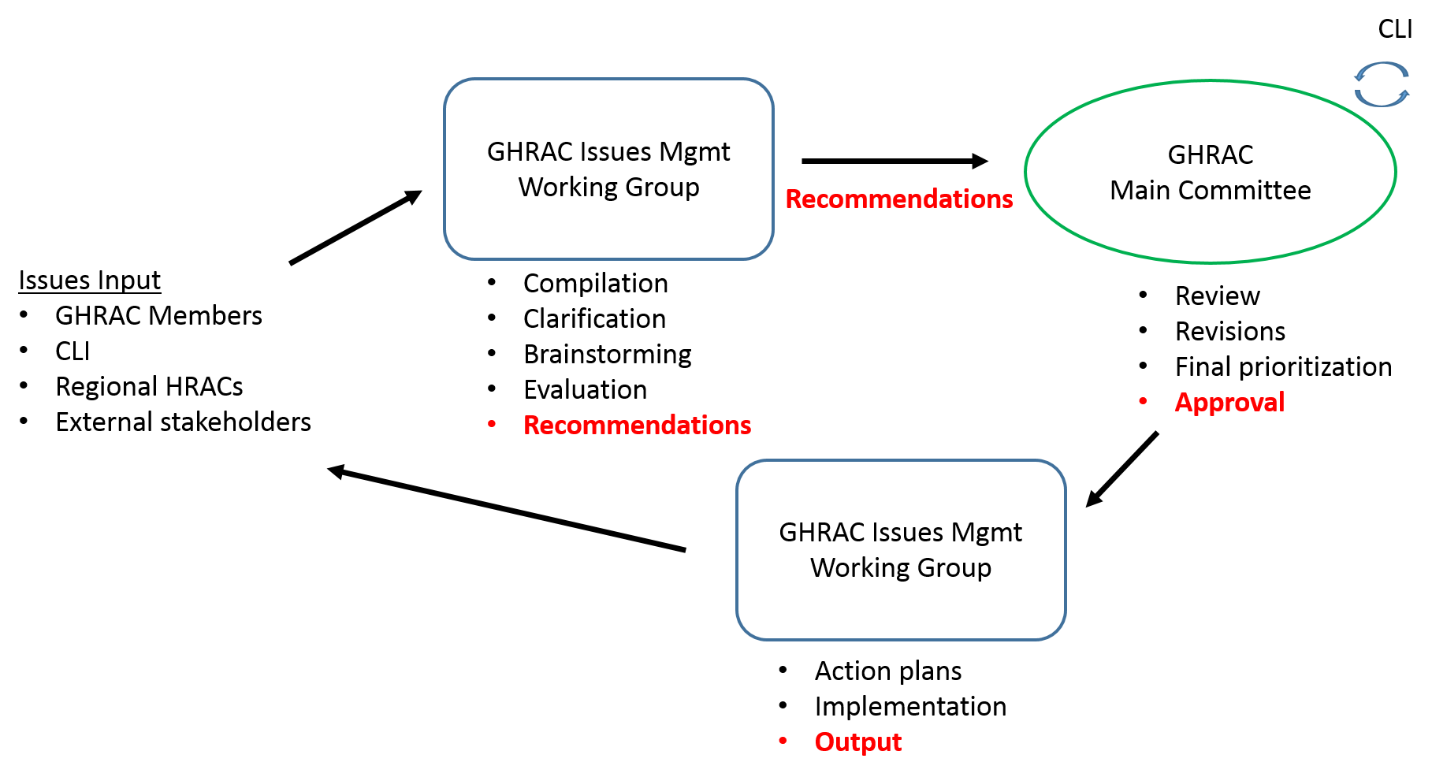
CLI Stewardship Committee

CLI Workshop Notes
- Understanding / awareness between areas and:
  - other RACs
  - local organizations
  - regulators
- Set up working groups on:
  - specific issues
  - (possibly) issue papers
- Commitment and organizational tools to provide rapid responses
- Visibility of Global HRAC actions and successes
- Global HRAC is the focal contact point for guidance
Notes
awareness across countries | have established good understanding between joint areas of cooperation with other RACs | other RACs are promoting our positions on selected issues to regulators
enable regional transportability of lessons learned | A set of issue papers to address prioritized projects | set up working groups on specific issues
set up issues management team to be proactive on issues related to weed herbicide resistance | task force gathering intelligence on global issues and offering talking points and guidance | have an efficient system in place to be able to respond [in a] timely [manner] (and ensure [consideration of HRAC viewpoint])
facilitate issues management globally | [achieve] alignment of industry  - [currently] reactive not proactive | industry has the capability to respond rapidly (it doesn’t necessarily have to be Global HRAC members, it could be locally [designated] people
read about an HRAC story in a trade publication

