

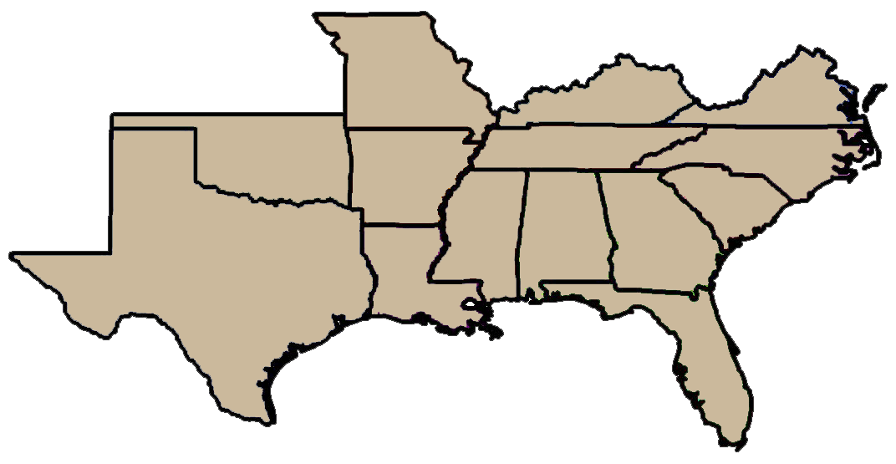


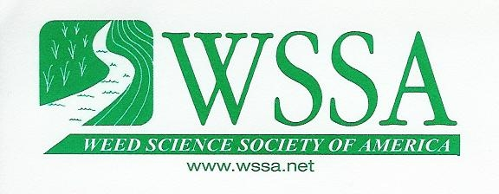
Southern
Weed Science Society
North Central
Weed Science Society

May 31, 2016
Docket ID: EPA-HQ-OPP-2016-0187

Environmental Protection Agency
Office of Pesticide Programs (OPP) Docket
EPA Docket Center (28221T)
1200 Pennsylvania Avenue, NW
Washington, DC 20460-0001

Subject: “Addendum - Resistance Management Plan (EPA-HQ-OPP-2016-0187-0012, pg 7-16)” as part of “Dicamba: New Use on Herbicide-Tolerant Cotton and Soybean”

The Weed Science Society of America (WSSA) and its affiliates, the Aquatic Plant Management Society, the Northeastern Weed Science Society, the North Central Weed Science Society, the Southern Weed Science Society, and the Western Society of Weed Science represent over 3000 members from around the world. Members include academic, governmental, and private industry research scientists, university extension professionals, educators, graduate students, and federal, state, county, and private land managers. Our scientific societies welcome the opportunity to comment on the resistance management plan included as an addendum in the documentation for the proposed registration of dicamba on dicamba-tolerant cotton and soybean. The WSSA also appreciated the opportunity to hear the elements of the proposed plan from EPA staff at its annual meeting in February.

The Resistance Management Plan Should be a Separate PR Notice:
The National and Regional Weed Science Societies are on record as supporting proactive measures by the Agency to combat the further evolution and spread of herbicide-resistant weeds (http://wssa.net/wp-content/uploads/Bradbury-Letter.pdf). The weed science community, comprised of academics, industry, consultants, and practitioners, recognizes the critical need to protect all available weed management tools. The resistance management proposal is a creative and comprehensive plan to deal with herbicide resistance and is a logical outcome from the comments made by Jack Housenger during his presentation at the 2nd Herbicide Resistance Summit (http://wssa.net/wssa/weed/summit-webcast/). However, the proposal also represents a significant change in how resistance is monitored, mitigated and communicated to weed management stakeholders. As such, it is troubling to us that the proposal was included as part of the proposed dicamba registration and not as a separate Pesticide Registration (PR) notice by itself. The policy implications of the proposal are significant enough to warrant this action; therefore we urge the Agency to follow with a PR notice solely on the herbicide resistance plan. This is particularly important as it is evident the Agency intends to apply the elements of the plan universally to future herbicide registrations. And, while members of our weed science societies may make comments specific to the proposed dicamba registration, the comments herein are specifically related to the concepts and implementation of the proposed resistance management plan rather than its use with any particular herbicide.

NOTE: After the above comments were agreed upon by the National and Regional Weed Science Societies, we are aware that the Agency posted “Draft PR Notice 2016-XX: Guidance for Herbicide Resistance Management Labeling, Education, Training, and Stewardship” (https://www.epa.gov/pesticide-registration/pesticide-registration-notices-year) and would like to thank the Agency and let you know that we will be commenting on that PR-Notice as well.

Use Only a Single Category for Herbicide Resistance Concern:
We understand that, as part of the registration and registration review of herbicides, the Agency’s Biological and Economic Analysis Division (BEAD) will review the stewardship and resistance management plans to determine if registrants have addressed the elements of the plan as part of that process. The items that BEAD will consider when reviewing these plans are based on the proposed 11-Element resistance management plan (EPA-HQ-OPP-2016-0187-0012; Table A, page 7 & 8). The proposal indicates that the number of recommended elements included for any particular herbicide will vary based on three escalating categories of herbicide resistance “concern” that will depend on the herbicide’s mechanism of action (MOA) and the number of weed species with evolved resistance to that MOA in the United States. The three categories of herbicide resistance concern are proposed as “Low Concern”, “Moderate Concern”, and “High Concern” (EPA-HQ-OPP-2016-0187-0012; Table B, pg. 10). In addition, herbicides for use in herbicide-resistant crops, either genetically engineered or conventionally bred, plus those with a new or novel MOA are considered “High Concern”. The National and Regional Weed Science Societies applaud many aspects of the plan and especially the educational component, but we propose that all herbicides be placed into a single category with respect to resistance concern and be treated equally.

Herbicide resistance in weeds occurs due to selection of a minute number of individuals within a population that contain genetic mutations that allow their survival following a herbicide application that would be lethal to a wild type. The repeated use of a single or multiple herbicides with the same MOA increases the risk of selecting for these individuals and increasing the proportion of resistant individuals in the population. While there is now a greater knowledge of the basis and frequency of resistance traits, and a better understanding that some herbicide MOA classes are more prone to quickly evolve resistance than others, we still feel it is important to protect all herbicides regardless of their resistance potential. As such, we recommend eliminating the proposed three categories of concern for herbicide resistance, and instead, place all herbicides into a single category with respect to resistance concern and be treated equally. This will simplify the plan for registrants and users, as there would be a consistent approach and communication about resistance management for all herbicides.

Comments on Recommended Elements for Any Resistance Management or Stewardship Plan (EPA-HQ-OPP-2016-0187-0012; Table A, page 7 & 8):

The National and Regional Weed Science Societies support the proposed Elements 1 through 4 as label recommendations for all herbicides. We are on record as supporting a requirement for MOA labeling on all herbicides (http://wssa.net/wp-content/uploads/Bradbury-Letter.pdf).

In addition, we are on record as supporting an emphasis on herbicide labels for using the full-labeled rate for any target weed in a cropping system (http://wssa.net/wp-content/uploads/Bradbury-Letter.pdf). However, the Agency needs to define the scope of where the use of these elements is directed. For example, is it meant to apply to all uses including aquatic situations, home lawn, garden, industrial, etc… or are the elements directed primarily at agronomic uses? In natural areas and aquatic sites, the Aquatic Plant Management Society stresses the need for maintaining flexibility in determining herbicide use rates and product selection remains critical in preserving a resource manager’s ability to enhance, conserve, or restore native vegetation. We would also like to point out that for aquatic herbicide applications, NPDES regulations mandate that the lowest possible discharge be conducted.

Element 5 would require placement of a definition of “likely resistance” on the label and, as part of the definition, guidelines would be given on the product label for visual, in-field evaluation for resistance. The National and Regional Weed Science Societies support and will be an active participant in the EPA’s goal to more rapidly and accurately identify newly evolving resistance. If some description of visual indications of resistance is deemed useful for product labels, we agree that the following cues, often referred to as the “Norsworthy criteria” and referenced in the Addendum, can be used as general indicators of a resistant weed population:

• Failure to control a weed species normally controlled by the herbicide at the rate applied, especially if control is achieved on adjacent weeds
• A spreading patch of uncontrolled plants of a particular weed species
• Surviving plants mixed with dead plants of the same species.

End users can also be directed to the WSSA education module, “Scouting After a Herbicide Application and Confirming Resistance” (http://wssa.net/wp-content/uploads/resistancemodules/four/index.htm). This module provides detailed instructions and visual examples on how to recognize herbicide resistance in the field and differentiate it from other causes of lack of performance (poor weed control).

Element 6 requires inclusion of instructions for reporting lack of performance by users to registrants or their representatives. Information on how to report product performance failures is often included on current labels and most farmers will contact their retailer and/or university extension specialist if they have a product failure. However, the requirement should allow sufficient flexibility to account for the range of performance complaint processes used by various registrants. One particular concern is how herbicide suppliers whose business model does not include performance guarantees or a field staff to investigate performance issues will meet this requirement. It is important that all registrants be held to the same requirements for resistance monitoring and management to achieve the objectives of the plan. One option EPA should allow for is third party or industry-wide monitoring and reporting arrangements to address the inability of some registrants to handle these activities with their own staff.

Once more common causes of herbicide performance failures (e.g. improper rate or timing, rainfall shortly after foliar applications, etc.) are ruled out, trained company representatives, certified crop advisors, or extension specialists can evaluate these situations for possible resistance and recommend follow up actions. These cases would be reported to the Agency and users as required in Element 8. The following reporting language is included in the proposed dicamba registration document (EPA-HQ-OPP-2016-0187-0016; VIII.C.1.c, pg. 34).

c. Annual Reporting of Herbicide Resistance to EPA
Monsanto must submit annual summary reports to EPA that include a summary of the number of instances of likely and confirmed weed resistance by weed species, crop, county and state. The annual reports must include summaries of the status of laboratory or greenhouse testing for resistance. The annual reports will also address the disposition of incidents of likely or confirmed resistance reported in previous years. These reports will not replace or supplement adverse effects reporting required under FIFRA §6(a)(2).

While similar to the above reporting language in the dicamba registration document, the National and Regional Weed Science Societies recommend that the following two categories of weed resistance cases be used for the reports required in Element 8 to deliver greater consistency, timeliness, and accuracy:

Category 1: Suspected Weed Resistance Cases. This category would be the total of all cases reported by the trained company representatives, certified crop advisors, or extension specialists suspected of resistance. It is vital to limit these reports to those evaluated by trained experts and that they not include resistance reports from outside this group. The heightened awareness of herbicide resistance in the agriculture community can make it a default diagnosis for lack of performance by untrained users.

We advise EPA not to use the term “likely resistance” for this category because it presumes a degree of certainty that the population in question will be confirmed as resistant. Instead, we suggest that EPA use the more neutral “suspected weed resistance” for this category. In addition to reporting the total number of suspected resistance reports, registrants should indicate which ones of these are under further investigation to confirm or deny potential resistance. If academics or industry personnel are investing the time and effort to investigate a potential resistance situation with in-field and/or greenhouse screenings, then they demonstrating a real concern that should be communicated appropriately.

Category 2: Confirmed Weed Resistance Cases. This category would allow academics and industry to provide scientific data confirming that a certain weed is resistant to a specific herbicide according to WSSA/HRAC guidelines each year. We feel that reports of new resistant species for a given MOA should be confirmed by appropriate lab or greenhouse testing.

This process would allow industry to provide details regarding weed resistance investigations and confirmed resistant cases each year with accuracy and more scientific merit than merely what is and what is not suspected to be resistant. This would help academics, industry and the EPA to achieve the goal of 1) accurate reporting, and 2) more rapidly communicating cases of suspected resistance to herbicide users. Basic information would include species, product, and use pattern (crop and application type) by state or Crop Reporting District (CRD). Detailed location and grower information would be withheld to protect privacy.

Since registrants will be responsible for summaries of weed resistance investigations on an annual basis, they will have an opportunity to review individual cases and determine the extent to which further investigation and testing is required. This emphasizes the need for cases to be reported to the registrant in a timely fashion if initial investigations are to be conducted by the registrant’s representatives.

The National and Regional Weed Science Societies believe that early reporting of suspected newly evolved resistance cases will be a critical part of a plan to alert the agricultural community in time to increase vigilance and institute mitigation measures before newly identified resistant weed populations become widespread. Separate groups in the WSSA and industry are currently considering the details and mechanisms of a reporting system(s) to accomplish this. We expect to have suggestions on reporting to share with EPA later this year.

Not included in Element 8 is a requirement for the reporting of the outcome of additional measures to control the suspected resistant population. However, this language is included in the
proposed dicamba registration material (EPA-HQ-OPP-2016-0187-0016; VIII.C.1.d, pg. 34):

d. Reporting of Likely Resistance to other Interested Parties
Monsanto must inform growers and other stakeholders of cases of likely resistance that are not resolved by the application of additional weed control measures.
We would suggest this language be included in Element 11 for clarity and consistency for all registrants.

In some instances, resistance in a weed species to a given MOA may become widespread in a given geography. At that point, there is limited value in the detailed investigation of new cases where resistance to an MOA is already widespread. For reporting purposes, a registrant may choose to indicate the widespread nature of the resistant biotype in a given area and cease further investigations. This designation could be made on the appropriate maps or tables in the annual reports supplied by the registrant. This also relates to Element 7 that requires a list of confirmed resistant weeds on the herbicide label. We recommend that the Agency allow the flexibility for having this information available outside the label, as is indicated for information covered in Elements 10 and 11. In this way, not only could resistant species be indicated but publically available maps could indicate those areas where the resistance is not yet known, those where it is infrequent, and those where it is so widespread as to make control with the product or MOA doubtful.

The National and Regional Weed Science Societies are pleased that the information covered under Elements 10 and 11 can be provided in ways outside of posting on the label. While the information requested by these elements may be of use to farmers, the logistics of placing it on product labels would be difficult. Keeping labels current by continually updating the list of resistant weeds would pose a significant burden on registrants and the EPA alike. It would be more effective to refer to an outside source for this information. In a similar fashion, a table outlining the effective MOAs for weed species and biotypes would be complicated and the objective of Element 10 may be better served via educational tools such as websites and apps.

We commend EPA for the focus on locally developed material in Element 9. This will make any recommendations more useful and practical for end users. Given that all users will be provided this material, it also insures they will be exposed to the educational component of the resistance management plan. However, EPA will need to clarify aspects of this plan because as currently written this element will potentially require a large program, with extensive resources, and implications across agriculture. Definitions for what is included in the plan, what entities are responsible for implementing the plan, and what “locally” indicates are needed. We would suggest that the language on locally developed material be included, as appropriate, in Element 11. These “additional specific requirements” may also need to be modified for local conditions.

We recommend that registrants developing resistance management plans refer to the list contained in the Executive Summary of the Norsworthy et al. 2012 paper (Norsworthy, J.K., S. M. Ward, D. R. Shaw, R. S. Llewellyn, R. L. Nichols, T. M. Webster, K. W. Bradley, G. Frisvold, S. B. Powles, N. R. Burgos, W. W. Witt, and M. Barrett. 2012. Reducing the risks of herbicide resistance: best management practices and recommendations. Weed Science 2012 Special Issue:31–62. Available at: http://www.wssajournals.org/doi/pdf/10.1614/WS-D-11-00155.1). By this approach, the resistance management plans would become more consistent and could include some or all of the following:

- In all cases, start with clean fields (no weeds present) and do not have emerged weeds at planting. Control any weeds present before planting using herbicides in conservation-tillage, otherwise use tillage as appropriate. Cover crops can also be used to suppress weed seed germination.

- When a herbicide is used, use the appropriate (full label) rate of the herbicide for the weed species and environmental situation present. Do not use rates lower than those specified on the product label. However, for aquatic herbicides, flexibility in herbicide use rates needs to be maintained.

- At planting and if possible, use a soil applied herbicide(s) with two different MOAs and with the maximum overlap in weed species controlled as feasible. Herbicide mixtures utilizing two or more different MOA’s applied at the same time are more effective at preventing weed resistance than a rotation of herbicide MOA’s where only one herbicide MOA is applied at a time.

- Apply postemergence herbicides in a manner to provide optimum control as indicated on the label. Generally, this means application to actively growing small weeds. Preferably, as with soil applied herbicide applications, use two different MOAs and with the maximum overlap in weed species controlled as feasible. In addition, it is best if these MOAs are different than those used for the soil applied herbicides.

- Control all weed escapes; do not let any uncontrolled weeds set seed; use hand-weeding when necessary. This includes control of weeds in field borders.

- Take extra sanitary measures (i.e. cleaning field equipment) to prevent movement of any resistant weed seed or other propagules from the affected field.

- Rotate crops to change the crop-weeds dynamic and to allow introduction of different herbicide MOAs.

For remedial plans, the emphasis should be on, as much as practical, preventing seed or other propagule production by the suspected resistant weeds. These approaches could include the use of additional herbicide treatments, particularly using herbicides with a different MOA(s) than those already applied. The use of a different MOA(s) than the initial products must be emphasized. The approach should not be additional treatment with products or MOAs already used. Non-selective herbicides (i.e. glyphosate, glufosinate, paraquat) could be recommended to control small isolated suspected resistant weed patches. Mechanical controls, including hand weeding, should also be considered. Finally, the plan should also address longer-term aspects such as crop and herbicide rotation, use of tillage and/or planting of cover crops.

The National and Regional Weed Science Societies previously recommended the approach taken in Element 10 that involves designating the specific weed species controlled by the individual components of multiple-herbicide products (http://wssa.net/wp-content/uploads/Bradbury-Letter.pdf). We agree that this information can effectively be provided in ways other than inclusion on the herbicide label.

We support Element 11 as a recommendation for all herbicide registrants. Each registrant would need to negotiate unique aspects for use of a given product with EPA. In addition, negotiated requirements should be consistent across all registrants of products containing similar active ingredients.

The National and Regional Weed Science Societies appreciate the opportunity to provide comments on the Resistance Management Plan that is an addendum to the dicamba-tolerant crops registration and look forward to working with the Agency on this important topic.

While we compliment the Agency on these proactive resistance management measures, it is important that it communicate to the agricultural community what are the expectations for the plan, how much it will cost to implement, and how will success (and failure) be measured. In addition, we consider the plan as a first iteration that will need adaption and evolution with our experience with it.

We hope the Agency plans to evaluate and revisit the plan at appropriate times during its use. WSSA would welcome the opportunity to partner with the Agency in the future refinement of the Resistance Management Plan.

Sincerely,

___________________________

Dr. Kevin Bradley
President
Weed Science Society of America

___________________________

Dr. Anita Dille
President
North Central Weed Science Society

___________________________

Dr. Peter Dotray
President
Southern Weed Science Society

___________________________

Dr. Rob Richardson
President
Aquatic Plant Management Society

___________________________

Dr. Shawn Askew
President
Northeastern Weed Science Society

___________________________

Dr. Kirk Howatt
President
Western Society of Weed Science

cc: House Committee on Agriculture
Senate Committee on Agriculture, Nutrition & Forestry
Dr. Sheryl Kunickis, USDA Office of Pest Management Policy

