HRAC Update - January, 2018
HRAC Membership
An updated membership list is being sent out by Roland. I’m sure further changes will be coming in 2018 as companies reorganize.
Communications Lead
Dawn Refsell will Chair our Communications Working Group and be Communications Lead for Global HRAC.
CLI Contact
Rolando Zamora has left his position with CLI and Andy Ward (Andrew.ward@croplife.org) will be assuming Rolando’s responsibilities such as processing invoices, etc.
Working Groups
Auxin Working Group: A paper summarizing the Synthetic Auxin Symposium at the GHRC 2017 has been accepted to Pest Management Science and is available online (http://onlinelibrary.wiley.com/doi/10.1002/ps.4823/full). The AWG is requesting US$4,400 for their 2018 budget to cover the open access charge. Updates to several of the auxin resistance fact sheets have been completed and should be available on the website shortly. Thanks to Bob Masters for leading these efforts. Minutes from last AWG meeting and a draft of criteria for new Auxin Resistance Fact Sheets are included in the appendix. Terry Wright (trwright@dow.com) has been elected Chair of the Auxin Working Group. Please contact Terry for upcoming meetings or updates.
HPPD Working Group: Contact Roland Beffa (roland.beffa@bayer.com) for upcoming meetings or updates.
Communications Working Group: A survey is going out to GHRAC stakeholders the week of January 15. This will help shape future implementation of the Communications Strategy. USHRAC and EHRAC are proceeding to develop their new websites within the GHRAC site. An email packet of regional logos and templates should be going out to the respective chairs in the next few weeks and will also be available on the GHRAC website. Please continue to use the Board Login section of the website to access documents and upload pertinent information. Contact Dawn Refsell (dawn.refsell@valent.com) for upcoming meetings or updates.
Issues Engagement Working Group: Continues to work on a whitepaper regarding resistance testing. The team is also working to address questions from various HRAC members related to the proposed ring test. Contact Harry Strek (harry.strek@bayer.com) for upcoming meetings or updates.
MOA Classification Working Group: The working group met via conference call on December 12. Key points of discussion were alterations to the chemical classifications within the HRAC SOA poster and tool. Proposals for reorganization of the synthetic auxins were reviewed. Contact Rex (rex.liebl@BASF.com) for further information.
PPO Working Group: This new WG is in the process of forming. Contact Rex (rex.liebl@BASF.com) for further information.

Regional Highlights
Argentina An Amaranthus quitensis biotype with multiple Gly + Auxinics (2,4-D and Dicamba) resistance identified in a very small area of central – northern Argentina. An Echinichloa crus-galli resistant to glyphosate biotype has expanded to over 3.5 MM ha during current season in Humid Pampa and Northwestern areas. HRAC Argentina is running four screening protocols testing the mostly MOA used in soybean on each the four key weeds in Argentina (AMACH, ERISU, ECHCG, LOLMU). Beyond almost Approximetly 90% of the soybean area in Paraguay is estimated to have ALS-R Conyza summatrensis and increasingly multiple Gly + PS I (Paraquat) resistance is being observed in the current season. Contact Rafael Frene (rlfrene@dow.com) for upcoming meetings or further updates.
Australia: Contact Jason Sabeeney (jason.sabeeney@syngenta.com) for upcoming meetings or updates.
Brazil: HRAC Brazil is evaluating a number of reports of new resistance cases in the country. They are also working with the planning committee for the Brazilian Weed Congress to be held in late August of 2018. Contact Caio Rossi (cvrossi@dow.com), Chair of HRAC Brazil
Europe: Contact Anne Thompson (anthompson@dow.com), Chair for EHRAC for more information.
US: USHRAC met in Washington DC on Jan 10 to review recent regulatory notifications from USEPA and discuss them with EPA officials. A number of concerns have been raised regarding the implementation of EPA requirements. See meeting notes in the Appendix. Contact Arlene Cotie (arlene.cotie@bayer.com) and for further information.
Asia: HRAC Asia team identified some priorities for Herbicide Resistant Management and Weed Control workshops in Asia in 2018. The first HRAC workshop has been tentatively planned in Vietnam for June 2018 and there is a desire to include someone from GHRAC or other international speaker on the program. Contact Luis Camacho (luis.camacho@monsanto.com)
RMPT Update
The CLI Resistance Management Project Team met on November 10, 2017 at CLA headquarters in Washington DC. Draft minutes of the meeting are attached below in the appendix.
Budget Update
The 2018 CLI-approved HRAC budget is $153,750. Working Groups and others that plan to have expenditures in 2018 should prepare detailed proposals within the two months. These should be actionable before the end of the year.

Miscellaneous Topics
Roland should be sending out meeting notices for our bi-monthly conference calls shortly. Our proposed face-to-face meetings are early April in Brussels and in conjunction with the Brazilian Weed Congress (August 27-31, Rio de Janeiro).

Please note the action register below. If something is missing, please contact Mark Peterson (mapeterson@dow.com).

Global HRAC Action Register

Auxin Working Group Notes and Proposals

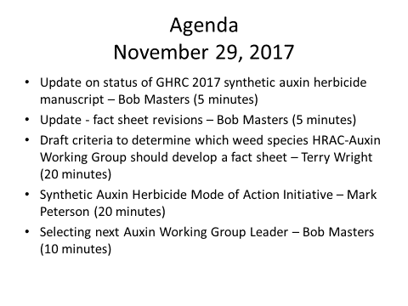
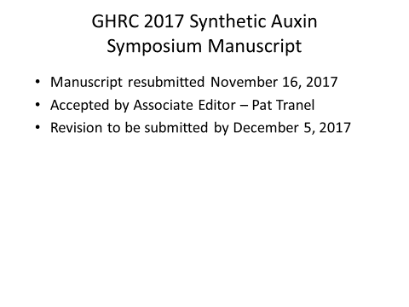
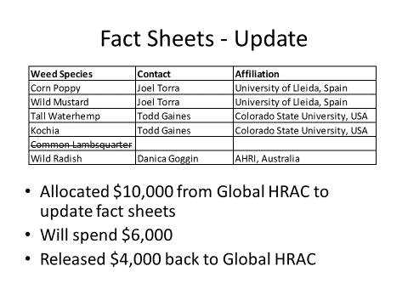

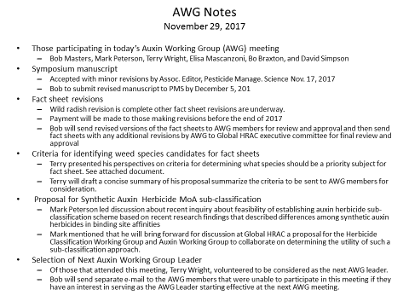

Draft criteria to determine which weed species HRAC-Auxin Working Group should develop a fact sheet. 10/1/17
T.R. Wright (Dow AgroSciences)

Currently there are 7 fact sheets for weeds resistant to synthetic auxin resistance on the HRAC website (1 general, 6 weed species).
From the introduction sheet:
Globally the most important synthetic auxin resistant weeds are Kochia, Wild Radish, Corn poppy, and Wild Mustard. Synthetic auxin resistance in two other species, tall waterhemp and common lambsquarters, are not widespread yet, but have the potential to become serious problems in the United States if they are not managed properly

What criteria was used when we initially choose 4 weeds (with two extra species)?
These species were chosen because
1) regionally, if not globally, important weeds with significant economic impact (weed control tactics significantly impacted by its precence).
2) the biotype is established (and possibly spreading)
3) issues with cross resistance and multiple resistance
4) level of resistance was noteworthy (high or low)

Because of 1-4, it was desired to have best management practices and help the industry understand the scope of the problem. The mechanism of resistance was not well known in most of these at the time the fact sheets were written. The recent Auxin resistance (GHRC-2017) symposium has pointed out new data developed since and is a reason to update the original fact sheets with mechanism and/or management / spread updates.

Additional criteria: I believe the criteria above are still appropriate. However, new cases could also 5) seek to clarify confusing or conflicting data. (e.g., if there are two or more resistance mechanisms in the same biotype, or if a new or unusual resistance mechanism is identified that may be informative for general awareness).

Or as a group discuss species that have been on the Weedscience.org website but are either 6) not growing as an issue or possibly disappear (e.g., yellow star thistle—first reported in 1988, last updated in 2000-acres no longer reported…last researcher of record in Washington has lived in New Zealand for 15 years). The purpose would be to identify which are ‘not significant problems’.
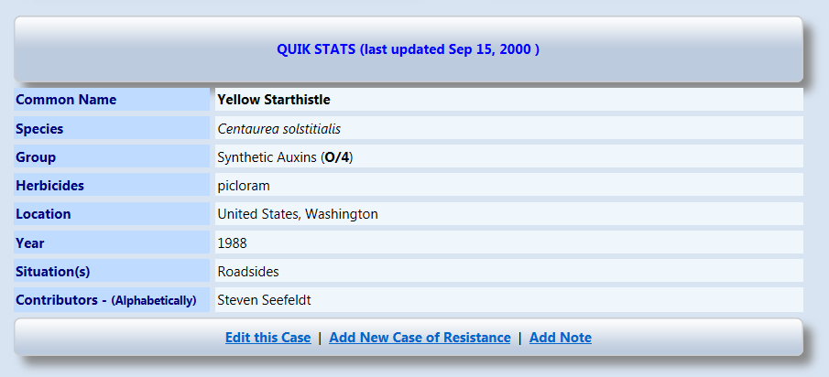

Suggestions for discussion.
Green---already done, update as necessary.
Yellow—add because interesting in important. (G. spurium—what is mechanism?) (Echinochloa spp—what (in layman’s terms) makes quinclorac resistant grasses different?) (S. orientale—significant issue in AU. Is it same or different than wild radish?).
Red – consider a bulk follow up on non-impactful biotypes (are these just novelties?) How many do we add to this? Is this useful?

Species | Country | First Year
Amaranthus tuberculatus (=A. rudis)  Tall Waterhemp | 2009 - United States (Nebraska) *Multiple - 3 SOA's  2016 - United States (Illinois) *Multiple - 5 SOA's | 2009
Arctotheca calendula  Capeweed | 2015 - Australia (South Australia) | 2015
Carduus nutans  Musk Thistle | 1981 - New Zealand | 1981
Carduus pycnocephalus  Italian Thistle | 1997 - New Zealand | 1997
Centaurea cyanus  Cornflower | 2012 - Poland | 2012
Centaurea solstitialis  Yellow Starthistle | 1988 - United States (Washington) | 1988
Centaurea stoebe ssp. micranthos  Spotted knapweed | 2013 - Canada (British Columbia) | 2013
Chenopodium album  Common Lambsquarters | 2005 - New Zealand | 2005
Cirsium arvense  Canada thistle | 1979 - Sweden  1985 - Hungary | 1979
Commelina diffusa  Spreading Dayflower | 1957 - United States (Hawaii) | 1957
Daucus carota  Wild Carrot | 1957 - Canada (Ontario)  1993 - United States (Michigan)  1994 - United States (Ohio) | 1957
Descurainia sophia  Flixweed | 2011 - China | 2011
Digitaria ischaemum  Smooth Crabgrass | 2002 - United States (California) | 2002
Echinochloa colona  Junglerice | 2000 - Colombia | 2000
Echinochloa crus-galli var. crus-galli  Barnyardgrass | 1998 - United States (Louisiana)  1999 - Brazil  1999 - United States (Arkansas) *Multiple - 2 SOA's  2000 - China  2009 - Brazil *Multiple - 2 SOA's  2013 - Uruguay | 1998
Echinochloa crusgalli var. zelayensis  Gulf Cockspur Grass | 2013 - China | 2013
Echinochloa crus-pavonis  Gulf Cockspur | 1999 - Brazil | 1999
Fimbristylis miliacea  Globe Fringerush | 1989 - Malaysia | 1989
Galeopsis tetrahit  Common Hempnettle | 1998 - Canada (Alberta) | 1998
Galium aparine  Catchweed Bedstraw | 2014 - China  2016 - Iran | 2014
Galium spurium  False Cleavers | 1996 - Canada (Alberta) *Multiple - 2 SOA's | 1996
Hirschfeldia incana  Shortpod Mustard | 2016 - Argentina *Multiple - 2 SOA's | 2016
Kochia scoparia  Kochia | 1994 - United States (Montana)  1995 - United States (North Dakota)  1997 - United States (Idaho)  1999 - United States (Colorado)  2009 - United States (Nebraska)  2013 - United States (Kansas) *Multiple - 4 SOA's  2013 - United States (Kansas) *Multiple - 2 SOA's  2015 - Canada (Saskatchewan) *Multiple - 2 SOA's | 1994
Lactuca serriola  Prickly Lettuce | 2007 - United States (Washington) | 2007
Limnocharis flava  Sawah Flowering Rush | 1995 - Indonesia  1998 - Malaysia *Multiple - 2 SOA's | 1995
Limnophila erecta  Marshweed | 2002 - Malaysia *Multiple - 2 SOA's | 2002
Papaver rhoeas  Corn Poppy | 1993 - Spain *Multiple - 2 SOA's  1998 - Italy *Multiple - 2 SOA's  1998 - Italy  2016 - France *Multiple - 2 SOA's | 1993
Ranunculus acris  Tall Buttercup | 1988 - New Zealand  2010 - New Zealand *Multiple - 2 SOA's | 1988
Raphanus raphanistrum  Wild Radish | 1999 - Australia (Western Australia)  2006 - Australia (South Australia) *Multiple - 3 SOA's  2009 - Australia (Victoria) *Multiple - 2 SOA's  2010 - Australia (Western Australia) *Multiple - 4 SOA's  2011 - Australia (Victoria)  2013 - Australia (New South Wales ) | 1999
Sinapis arvensis  Wild Mustard | 1990 - Canada (Manitoba)  2008 - Turkey *Multiple - 2 SOA's | 1990
Sisymbrium orientale  Oriental Mustard | 2005 - Australia (South Australia) *Multiple - 2 SOA's | 2005
Soliva sessilis  Lawn Burweed | 1999 - New Zealand | 1999
Sonchus oleraceus  Annual Sowthistle | 2015 - Australia (South Australia)  2015 - Australia (Victoria) | 2015
Sphenoclea zeylanica  Gooseweed | 1983 - Philippines  1995 - Malaysia  2000 - Thailand | 1983
Stellaria media  Common Chickweed | 1985 - United Kingdom  2010 - China | 1985

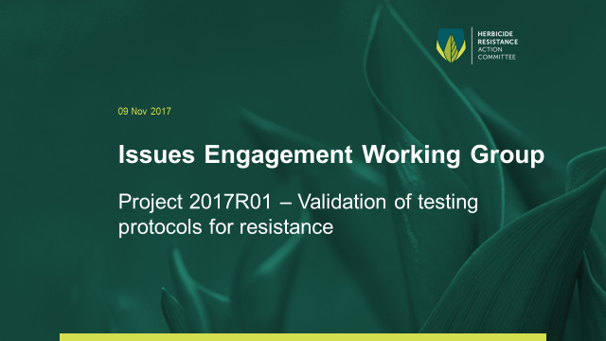
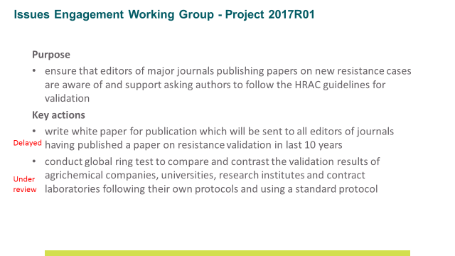
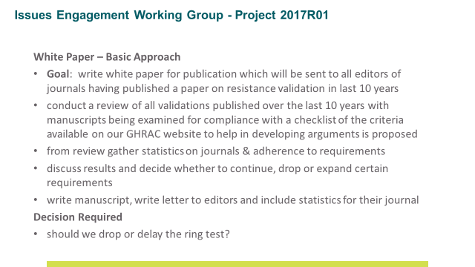

Draft Minutes of Nov2017 RMPT Meeting, Washington, DC, USA
Prepared by: | R. Zamora, A. Ward
Date: | 15 November 2017
Reviewed by: | R. Hunter
Status: | DRAFT
To: | Resistance Management Project Team

Title: Resistance Management Project Team
Date: 10 November 2017, 8:00 – 14:00 EDT
Venue: CropLife America, 1156 15th ST. NW, Washington, DC

Attending in person:
NS Nick Storer Dow
CBL Christine Brunel-Ligneau Bayer
RL Rex Liebl BASF
GH Graham Head Monsanto
KN Kazuhiko Nishioka Sumitomo
MP Mark Peterson HRAC
LH Les Hillowitz CropLife Africa Middle East
GB Gabriela Briceno CropLife Latin America
AT Andreas Thierfelder ECPA
AW Andy Ward CropLife International
KJ Keith Jones CropLife International
RH Robert Hunter CropLife International
RZ Rolando Zamora CropLife International

By phone:
IA Ian Affleck CropLife Canada
DS Danielle Soulard CropLife Canada
HD Dietrich Hermann FRAC
RS Russell Slater IRAC

Regrets:
DO David O’Reilly Syngenta
JD Jenny Dowil DuPont
SE Stefan Endepols RRAC
RM Ray McAllister CropLife America
AR Andrew Roberts CropLife Asia
WS Will Surman CropLife International

Welcome and Introductions

RH welcomed everyone to the meeting.

- Antitrust Reminder

RH reminded all members of their obligations under the CropLife International Antitrust Guidelines.

- Adoption of the agenda

The agenda was approved.

- Approval of the minutes from previous meetings

Minutes from the previous meeting were approved.

- RAC Updates (more details in slide decks sent on 10 Nov 2017)

IRAC: RS provided an update on the IRAC membership noting that Nufarm may re-join after leaving the group last March 2017. Main IRAC activities include a discussion paper for classification of non-synthetic chemical actives; proposal for data generation towards EU regulations and effective engagement with EU authorities; improvements in the IRAC website (e.g. provide more crop- specific recommendations); and a more user-friendly interface for the insect resistance database managed by Michigan State University. A new working group on nematodes was recently formed (kick off meeting held in September) as well as a new task force in Africa to tackle Spodoptera frugiperda. IRAC seeks guidance from the RMPT on improving communications towards the right audiences, but also farmer training through the CropLife network (e.g. on-line IRM training and in-person training).

HRAC: MP provided an update on the HRAC membership noting that ADAMA is no longer a member. Company staff involvement in HRAC is challenging given the current industry landscape so several HRAC positions have changed. The group is also considering hiring a coordinator for workload relief. There are 6 working groups at global level, and several established local groups (e.g. USA) and some others in forming stage (e.g. Mexico). The membership of some of these local groups is unclear, which will be addressed by the regional survey exercise that is underway. In 2017 HRAC increased their global public participation (e.g. Global Herbicide Resistance Challenge 2017) and going forward, HRAC would like to broaden membership at the global level.

FRAC: DH noted that aside from Asia-Pacific that joined FRAC in September, there are no changes in the membership. He provided a detailed summary of key actions and progress, noting that in general the communication among RACs has improved over the last year. FRAC will roll out the new non-member policy in December, when the working groups will meet. This will present an opportunity to amend various sections of the FRAC constitution. In 2018, FRAC will form a new working group in soybean which is the second crop-focused working group in FRAC. They see CropLife International playing a key role in farmer training, and pushing communications to key stakeholders.

RRAC: Slide deck was circulated for information.

- Mode of Action Labelling review

KK updated the group on the status of the mode of action labelling. Company representatives at the RMPT will serve as a focal point to coordinate/support the implementation which will be done by each company on a voluntary basis. The role of the RMPT will be to provide guidance on how to measure progress, monitoring and reporting by setting up KPI’s. A question was raised about managing approvals from authorities on labelling requirements, and it was clarified that this is something for each company to work out through their regulatory teams in the countries. Engaging with non-members was mentioned as a key component that should be part of the communication plan. It was also noted that there are countries advancing MoA labelling with the authorities (e.g. Malaysia). RH noted that developing communication materials would be the priority for the project team in order to start to inform stakeholders on the commitment and what it means for the industry. A communication plan would be developed to prepare the network for longer-term engagement on the issue.

Actions:
- CropLife International to prepare a communication document explaining the MoA commitment to be prepared by end of November.
- CropLife International to develop a longer-term communication plan on the MoA commitment for the CropLife network.

- CropLife International non-member policy

RH updated the group on the non-member policy and noted that the Board approved the policy at their meeting in September. The policy makes clear that there is no obligation for CropLife International to accept non-members in their project teams, however if necessary, guidance is provided on how this can be fulfilled. The policy provides guidance on criteria for eligible non-members as well as a new fee structure. So far feedback from non-members participating in HRAC and RRAC has been positive, however further feedback is expected from the other RACs in the coming months. The group suggested providing a written factsheet for those eligible non-members interested in joining including the type of information they need to provide to be admitted.

Actions:
- CropLife International to provide guidance to the RACs on the information non-members need to provide during the admission process.

- Regional CropLife network updates (more details in slide decks sent on 10 Nov 2017)

Asia: slide deck circulated for information.

Latin America: GB provided an update on the activities carried out by the various RAC groups in Latin America, highlighting the formation of a soybean FRAC in Brazil, which is requesting guidance from global FRAC, e.g. on communications. The group appreciated the update, however requested GB report on the training activities done by CropLife Latin America and/or local crop protection associations rather than activities by the local RAC groups (e.g. farmer training on resistance management, training materials, etc.). This will help the RMPT understand the interaction, monitoring and level of engagement between the local RAC groups and the industry local associations.

Africa: LH provided an update on the activities carried out by the various RAC groups in Africa Middle East. Each local group is working closely with the respective CropLife trade association in the country and CLAME provides monitoring and support. In addition to this, there is a core module on resistance management under the SSP program which is being utilized to train more than 10,000 SSPs in the region.

Canada: IA provided an update on the RAC group under CropLife Canada. This group is an administrative group with no technical discussion at this point. Currently the group is focusing on surveying farmers in Canada (500-600 farmers) to gather evidence/data on resistance issues with the aim of improving outreach and farmer training. The group will share the draft survey with the RMPT for information purposes and will present a report by 2Q 2018.

Europe: RZ noted that the Sustainable Management of Agricultural Resistance Threats proposal (SMART) drafted by the multi-stakeholder consortium is a smaller and streamlined as compared to the previous version rejected by Horizon 2020. The new proposal aims to raise awareness of resistance issues in Europe, and it will look at 6 crops and their main biotic threats in pests, weeds and pathogens. It includes evidence gathering, socio-economic impacts (MP offered to share paper on socio-economic impacts in weed resistance in Germany) and the publication of a peer-review paper. Findings will be used to formulate further proposals for EU funding. Total budget has not been determined yet. RMPT supported the idea of the project and RACs noted their interest too. The group requested a clear budget request before making any final decision. It was pointed out that CropLife International does not have a budget allocated for this for 2018.

Actions:
- CropLife International to provide information to the RMPT on activities that could add value to RMPT activities.
- GB to provide a report on CLLA training activities (e.g. farmer training on resistance management, training materials, etc.).
- MP to share paper on socio-economic impacts of weed resistance issues in Germany.
- RZ to provide budget request for the SMART project.

- Communications update

No discussed due to time constrains.

- Global strategy review

The group reviewed the goals 2020, KPIs, strategy and the key actions 2016-2020. A summary of progress made on the key actions 2016-2020 was registered and it will be shared with the group in the coming weeks. Due to time constrains, the group did not discuss the ambition and global strategy and how these add to the strategy, goals and key actions reviewed by the group. It was agreed that the Secretariat will set up a sub-team to take a first attempt to combine both documents.
Actions:
- CropLife International will collate and update progress report on the Vision 2020 under resistance management.
- Ad-hoc teams will be established to coordinate the Vision2020 and global strategy document to cover key areas in the strategy such as communications, advocacy, training and implementation. Volunteers for the ad hoc teams were CBL, GH and DO.

- AOB

No AOB were discussed.

Meeting adjourned.

Meeting Notes for HRAC-US, Jan. 10, 2018
Meeting location: CLA headquarters, 1156 15th St. NW, Washington, DC 20005

Attendees
Name | Company | Attending
Andy Kendig | ADAMA | No
Peter Porpiglia* | AmVac | Yes
Arlene Cotie* | Bayer | Yes
Siyuan Tan* | BASF | Yes
Shane Hennigh | BASF | No
Mike Moechnig* | Dow | Yes
David Simpson | Dow | Yes
Craig Alford* | DuPont | No
Dave Johnson | DuPont | No
Sandra Shinn* | FMC | No
Paula Price* | Monsanto | Yes
Greg Elmore | Monsanto | Yes
Dane Bowers | Syngenta | Yes
Carroll Moseley* | Syngenta | No
Dawn Refsell* | Valent | Yes
Other Representative
Mark Peterson | Global HRAC | No
Ray McAllister | CLA | Yes
Amanda Maizel | CLA counsel | Yes
Rachel Lattimore | CLA counsel | Yes
* Voting member

Antitrust review

PRN 2017-2 discussion among HRAC members prior to EPA meeting
Concerns with reporting suspected resistance
- Confirming resistance can take years and procedures can vary among scientists. Global HRAC is working on defining standards for confirming herbicide resistance.
  - When considering standardized approaches, should there be a lack of control threshold that indicates decreased herbicide activity beyond normal variability? There may be a threshold like this already used for insect control in cotton.
- Uncertainty on how EPA will use resistance reports. Could affect registrations?
- New PRN is first time EPA uses “suspected” resistance reporting associated with registrations. PRN 2017-2 states both suspected and confirmed resistance must be reported according to 6(a)(2) guidelines described in 40 CFR 159.188(c) which states:
“(c) Development of pesticide resistance. Information must be submitted concerning substantiation of any incident of a pest having developed resistance to any pesticide (both public health and non-public health) that occurred under conditions of use, application rates and methods specified on the label if either of the following conditions is met:
- The survival of the suspected pesticide-resistant pest was significantly higher than that of a known susceptible pest when both the suspected resistant and susceptible pests were treated with the pesticide under controlled conditions.
- Biochemical tests or DNA sequencing indicate that the pest is resistant to the pesticide.”
  - Although the term “suspected” is mentioned in part (1) above, the text is defining typical greenhouse tests (or controlled conditions) used to confirm if a “suspected” biotype is resistant by comparing herbicide response to a susceptible biotype. Therefore, conditions for reporting are met only if “the survival of the suspected pesticide-resistant pest (is) significantly higher than that of the susceptible pest” under controlled conditions. It may be a misinterpretation to suggest that 40 CFR requires all suspected cases to be reported regardless of any effort of confirmation.
- It seems EPA is now asking for two sets of resistance reporting, including 6(a)(2) and reports associated with new herbicide-tolerant crops.
- Once suspected resistance is reported in a database, how can it be removed if confirmed not resistant?
- Some questions regarding what is actually required for 6(a)(2) reporting. Is it required to report cases if they are already published and available to the public (e.g. if a company discovers resistance from university reports on weedscience.org, do they need to report)? Also, must 6(a)(2) reports be location specific?
- There may not be uniform implications or expectations among companies as large companies with many field representatives will have greater awareness and expectations for reporting whereas smaller companies with few representatives may be largely unware of many new resistance cases.
Alternatives for reporting resistance directly to EPA:
- Potential alternatives to 6(a)(2) reporting were discussed. However, Peter mentioned that he had discussions with EPA about 1 yr ago regarding insecticides and EPA seemed determined to maintain the 6(a)(2) reporting requirements. The full implications of 6(a)(2) reporting are not known as it is not clear how EPA plans to use this information regarding registrations or potential use restrictions. Below, several alternatives include some sort of annual update that include academia, but for EPA acceptance as a reporting alternative, there may need to be assurances that these meetings will be consistent and standardized and perhaps some sort of summary report may be needed.
- Annual update meeting or symposium: Perhaps a yearly meeting similar to what is currently being done at the Beltwide Cotton Conference for Bt resistance. Those presentations are usually dominated by University scientists, but industry is often working with these scientists/projects. However, an effort may be needed to ensure resistance testing procedures are uniform and broadly accepted. It was suggested to have additional discussions with people who have had challenges with this conference in the past before a final decision is made to adopt this approach.
- Updates at WSSA: Provide annual updates to the New Herbicide Resistant Plants Committee or through an HRAC-US sponsored event. It seems like the Resistant Plants Committee is currently not highly active. There used to be reports from each region (including detailed lists of who is working on what), now just a loosely structured voluntary discussion. It is recognized that some academics are reluctant to share new cases they are working on for fear that somebody else may be able to publish the case before them. Would need to be inclusive of many groups (maybe including insecticide/fungicide).
- Coordinated effort through CLA: May be best to coordinate through existing organizations, such as WSSA. Prior to pursuing this option, CLA would have to investigate potential implications.
- Forums hosted by USDA or EPA: Would likely require public announcement so NGOs or activist organizations could potentially attend or participate.
- Joint industry surveys: Perhaps industry could work together, maybe through HRAC, to collaborate on gathering and submitting information on new resistance cases. Otherwise, growers could be exposed to numerous surveys from multiple companies. However, this may require legal counsel to ensure no antitrust violations.

Herbicide resistance management plan
- David Simpson provided a summary of the herbicide resistance management plan he has been working with the WSSA sub-committee
- The purpose is to develop a plan that could be implemented by a growers, using an IWM approach that includes multiple tools
- It was suggested that eventually the plan outline could be used to develop a decision tool for growers, but this tool would have to avoid making product recommendations (focus on ai or mechanism of action). This could create challenges as farmers generally have a limited understanding of mechanisms of action associated with common products. Some commercial decision tools already exist, for example, AgPhD has an app. that helps customers identify the MOA of several different pesticides. University of Nebraska had a decision aid web site but discontinued due to legal concerns.
  - Perhaps it would be best if any potential decision tools were developed by organizations other than HRAC to avoid potential antitrust suspicion. Even if HRAC provides financial support for such a tool, a document may be needed to demonstrate transparency regarding how the tool works to avoid suspicions of bias or antitrust.
- Perhaps there are additional partnerships that should be explored, such as the NAICC (national alliance of independent crop consultants) or ag industry associations (e.g. Take Action), who have interest in resistance management recommendations.

EPA meeting to discuss PRN 2017-2:
Attendees include HRAC-US members noted above, Jill Schroeder (USDA), Bill Chism (BEAD), Greg Krueger (WSSA-EPA liaison), Karen Kaine (Bayer, herbicide regulatory, Chair of CLA registration committee), Kelly Tindle (BEAD), Amanda Maizel (Counsel for CLA)

The meeting started with personal introductions and an introduction of US and Global HRAC, which included the new websites, sponsorship of weedscience.org (international survey on resistant weeds), WSSA efforts on the Herbicide Resistance Management plan (David Simpson), and the IPRMP (Iowa initiative, discussed by Peter Porpiglia).

Comments from Bill Chism (BEAD)
Resistance reporting
- Reasons for reporting requirements: Industry has reported confirmed resistance well, particularly through efforts such as weedscience.org, but to more quickly mitigate new cases of resistance, reporting of suspected cases or cases of on-going investigation should be reported publicly. Currently, it may not be clear that there are potential resistance outbreaks among neighboring land managers (at the local level) or adjacent states (at the regional level).
  - The best or most effective approach to accomplish this is still not perfectly clear to EPA, so they are still open to new ideas.
  - To assist mitigation, it will be important that a remedial plan exists.
  - Regarding requirements for “suspected” resistance reporting, Chism suggested that 6(a)(2) language (1998 40 CFR paragraph) has included requirements for reporting suspected and confirmed resistance.
    - Bill was challenged on the requirement to report suspected resistance several times, but seemed convinced that the 40 CFR language clearly indicated both suspected and confirmed resistance must be reported in accordance with 6(a)(2).
    - However, Chism acknowledged that reports of suspected resistance could be counter-productive if this made resistance reporting diluted with misinformation or made confusing. Chism expressed interest in alternative approaches that could be more effective in getting info to consultants and other users in a timely manner for rapid mitigation.
  - Chism also acknowledged, with some frustration, that resistance reporting through 6(a)(2) has been poor. For example, they suspect only about 10% of herbicide resistance cases are reported and maybe there were only 10 reports on insecticide/fungicide resistance since the requirement was enacted. Consequently, the primary reporting concerns now are associated with insecticides/fungicides rather than herbicides.
  - Jill Schroeder suggested that we really need an approach similar to EDRR (early detections and rapid response) used for invasive species to quickly mitigate and prevent the spread of resistant biotypes.
    - Additionally, Jill reminded the group that one of the key learnings from the resistance listening sessions was that some important groups/people may not be reached by resistance management messages or concerns. There will be a discussion session regarding the listening sessions at WSSA.
- What needs to be reported:
  - HRAC suggested additional clarity on reporting requirements needed and procedures required for verifying resistance.
  - Chism clearly indicated that new cases observed in public documents or websites, such as weedscience.org, should still be reported under 6(a)(2) even though it is already publicly available. Ray McAllister disagreed with this interpretation, but Chism insisted that their lawyers would support that claim.
  - For reporting new cases where resistance commonly exists (such as new glyphosate resistant cases of common weeds, such as waterhemp), Chism urged using common sense to prioritize needs and concerns.
  - Greg Kruger acknowledged that some university scientists will be reluctant to share new resistance cases for fear of having somebody else publish the information before them.
  - If there is a report of suspected resistance that is later confirmed to not be resistant, Chism suggested that perhaps a foot note could be entered into the entry in the reporting system or there could be some other way to communicate this change in status.
- Alternatives EPA may consider:
  - Perhaps EPA may consider an updated PRN for additional reporting options or other clarification on changing requirements. It may be possible to incorporate changes with the planned updates to the fungicide and insecticide PRNs.
  - Chism urged continued dialogue with EPA regarding reporting concerns and potentially helpful alternatives.
  - When considering alternatives, priorities should be identified to clearly indicate which species should be focused on, target audience (who to communicate the information to), and how to reach targeted audiences.
    - Perhaps more information should be provided regarding how the use of the product affects resistance. For example, some MOAs may have resistance to POST applied products but not PRE applied products.
- How will resistance reports be used:
  - Information could be used for registration changes as resistance surveys could be one part of a review on environmental impact. For example, they have often referenced weedscience.org when assessing the benefits of registrations on crops.
  - Uncertainty if current resistance reporting will result in changes among applicators (seemed to be one learning from the listening sessions).

Methods to improve web-search visibility of management plans
- Several management plans exist among states and organizations, but they can be difficult to find on the internet. In addition, if found, it can be difficult to determine the date it was posted or if it is the most recent version.
- Chism suggested using targeted key words to make it easier to find management plans (perhaps 2 to 4 key words)
  - May be easier to do this in ‘RACs than society web sites, which can be complex.
  - Dawn indicated that key word functionality is not like it once was. For example, now fees to Google may prioritize search results. One concern is that PDF documents have no key word search functionality (HRAC website developers have been considering this potential challenge).
  - Maybe need to get advice from others, such as Take Action
  - Perhaps consider other places for posting plans, such as HRAC, WSSA information portal, Take Action, or others.

Future actions
PRN 2017-2
- Action: Need to organize concerns in one place for legal review and review by others. We have not formally summarized concerns with new PRN yet.
- Need to consider Bill’s intent that there may be flexibility with 6(a)(2) reporting, but his intent does not seem clear in the PRN document. Why? Should we check with others in EPA on opinions regarding 6(a)(2) reporting? Perhaps others may believe suspected resistance reporting is a more important requirement. Bill expressed his intent and interpretation, but is that the intent of EPA as a whole? During Chism’s discussion, he briefly mentioned that “Rick in his office” may be open to considering alternatives to reporting suspected resistance (not sure who that is, but may be useful to find out).
- Consider a strategy to get the PRN revised to clarify reporting suspected resistance, at the same time it may be beneficial to offer an alternative.
- Should we make an effort to inform EPA about current industry efforts to prevent and mitigate herbicide resistance?
  - Perhaps there should be documentation of industry efforts to prevent resistance, investigate suspected cases, and mitigate outbreaks? Would that satisfy EPA’s needs or objectives?
    - Still does not resolve lack of small company participation and responsibility
    - EPA will likely not treat all products with the same level of concern
- CLA will look into PR-notice and make a reasonable request to change terms
  - Action: HRAC send list of concerns to CLA
- HRAC meeting at WSSA
  - There is a scheduled HRAC meeting, via Web-Ex, Wednesday, Jan. 24 at 8:00 am CST
  - Arrange a time to meet at WSSA? Rosslyn 1 room at 2 pm Monday (Mike will check with local arrangements (contact may be Bill?))
Meetings in the future
- Review strategies, effectiveness, and changes going forward
- Face-to-face meeting March 28 in St. Louise? Maybe consider if inviting others for additional insight, such as how other groups have handled resistance. Consider hiring moderator.
- May need focus on education efforts. Progress being made with Take Action (Dawn will be on the Take Action advisory committee)

